Exp no: 3 Keerthika.K
241901046

UDP Client–Server using Socket Programming in Python

AIM:
To write a Python program to implement communication between a UDP client and a UDP server using socket programming.

INTRODUCTION:
UDP (User Datagram Protocol) is a connectionless communication protocol used for transmitting data without establishing a dedicated connection between the sender and receiver.
Unlike TCP, UDP does not guarantee reliable or ordered delivery of data, making it faster and suitable for applications like video streaming, voice calls, and gaming.
In UDP socket programming, the server listens for incoming datagrams, and the client sends messages without needing to establish a formal connection.

ALGORITHM (Server Side):
- Start the program.
- Import the socket module.
- Create a UDP socket using socket.socket(socket.AF_INET, socket.SOCK_DGRAM).
- Bind the socket to a specific IP address and port using bind((host, port)).
- Wait to receive data from a client using recvfrom().
- Display the received message.
- Send a response back to the client using sendto().
- Repeat steps 5–7 as needed.
- Close the socket.
- Stop the program.

ALGORITHM (Client Side):
- Start the program.
- Import the socket module.
- Create a UDP socket using socket.socket(socket.AF_INET, socket.SOCK_DGRAM).
- Define the server IP address and port number.
- Send data to the server using sendto().
- Wait for a response from the server using recvfrom().
- Display the server’s response.
- Close the socket.
- Stop the program.

Server (code):

import socket
sockfd = socket.socket(socket.AF_INET, socket.SOCK_DGRAM)
print('UDP Socket Created')
sockfd.bind(('localhost', 55555))
print('Waiting for client messages')
while True:
receivedMsg, addr = sockfd.recvfrom(1024)
receivedMsg = receivedMsg.decode()
print("Connected with ", addr)
print("Message Received from Client: ", receivedMsg)
sockfd.sendto(bytes(receivedMsg, 'utf-8'), addr)
print("Message reply sent to Client!")
print("Do you want to continue(type y or n):")
choice = input()
if choice == 'n':
break

Client (code):

import socket
clientfd = socket.socket(socket.AF_INET, socket.SOCK_DGRAM)
name = input("Enter your message: ")
clientfd.sendto(bytes(name, 'utf-8'), ('localhost', 55555))
receivedMsg, server = clientfd.recvfrom(1024)
print("Message Received from Server: ", receivedMsg.decode())

Server (status):

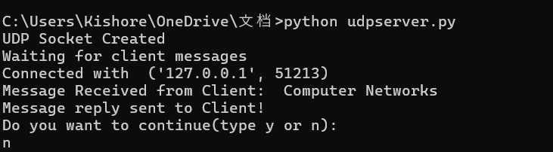

Client (status):
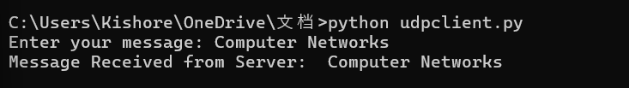
RESULT:

The UDP client-server communication program in Python was executed successfully.
The client sent a message to the server, and the server responded correctly, demonstrating successful datagram-based (UDP) communication.

